Trish Thorpe  Going Rural Health | The University of Melbourne Department of Rural Health  806 Mair Street, Ballarat VIC 3350

Student Placement Survey Report: January-December 2020
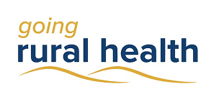
Trish Thorpe

Introduction
Going Rural Health (GRH) is a student program that supports nursing and allied health students to complete rural clinical placements. At the end of their placement, GRH students are invited to complete a placement evaluation survey. This report is a brief summary of the survey responses from students who completed a placement in 2020.

The COVID-19 Context
Many regional and rural health care services ceased all clinical placements between April and June, and aged care placements were ceased at the direction of the Victorian Department of Health in August. Travel restrictions reduced student numbers of metropolitan origin coming to rural locations for placements. Many allied health disciplines stopped placements altogether for at least part of the year.
GRH provided considerable accommodation support to students, to ensure placements continued safely when the university’s accommodation was closed. Most university accommodation sites re-opened at restricted capacity in the second half of the year. Creswick accommodation (near Ballarat) still had not reopened by the end of December.
GRH staff worked remotely from home from late March to December. To continue to connect with students and provide social supports, interdisciplinary online student engagement events were organised in collaboration with the Rural Clinical School team, and the Regional Training Hubs from both Ballarat and Shepparton. The events helped to mitigate social isolation, particularly when the state was in hard lockdown in the second wave.
The education team pivoted to provide education support despite the restrictions. Many education sessions were adapted to an online format, and made available to staff and students on the GRH website. Education sessions were also offered virtually. These were promoted via social media platforms, the new GRH newsletter, and directly at meetings.
GRH staff worked hard to adapt to each new challenge as it presented, offering extra support as required to students, health services, and universities during this difficult time.
Students had varying responses to the challenges associated with COVID-19, and its effect on their rural placements. Some comments from students included:
‘Was very stressful and did not receive much information from uni or hospital on what was going to occur for students. Had to actively seek information.’
‘I absolutely loved this placement and was devastated at it having to be prematurely cut short by 2 weeks due to the COVID-19 pandemic. However I completely understand and agree with the reasoning behind this.’
‘Very thankful to everyone for helping get us as far through the placement as possible until it was unfortunately cancelled due to COVID-19.’
‘Much of my experience was impacted by the COVID-19 pandemic. This meant less patients were coming through and subsequently, less work and experience for me as a student. I believe if this had not have been the case, the placement would have been incredibly valuable. However, this is out of our control and I still learnt a lot with the patients I was able to see.’
‘It was conducted through Covid-19, our accommodation only provided us 30 hours notice to leave the premises. I would have liked more time to move…’
‘The experience was affected by COVID 19, so unfortunately was not as long as expected. Although this was not in the placement site's control, we would've appreciated more communication between the site and us regarding the situation and how we fit into that.’
Many students also expressed appreciation that health service staff were still willing to provide them the level of support they received on their placements, during what would also have been a stressful time for health professionals.
‘Staff were very encouraging, particularly through such a hard time for everybody during the COVID-19 restrictions and changes.’
‘Extremely well supported placement given the current circumstances of Covid-19. GRH as well as placement providers could have not have been of more assistance.’

Student Demographics
Approximately 700 survey responses were collected from the student survey. Approximately two thirds of these placements were completed in the second half of the year. This was slightly fewer compared with 2019. Of the respondents, 86% of students were female. Student age ranged between 17 and 60 years. 66% of students had lived in a regional or rural area previously. 70% were nursing students, a slightly higher proportion than other years due the number of cancelled or interrupted allied health placements. Despite this, fifteen allied health disciplines were represented. Students came from 18 different education providers. 71% of placements were located in a public hospital.

Placement Satisfaction

90% of Going Rural Health students were satisfied with their overall rural placement experience
Going Rural Health students in general reported very positive rural placement experiences. There was a slight decrease in overall satisfaction for the year, compared with the first half of 2020.
Of those who indicated dissatisfaction (2%), they either provided no comments, that COVID impacted their placement (access to patients, telehealth) or they were dissatisfied with their clinical supervisor or the amount of clinical supervision provided.
Positive aspects reported by students included:
- Welcoming and friendly staff, patients and community (57%)
- The variety of patient presentations and learning experiences (38%)
- Staff time given to support learning (24%)
- Teamwork, within and across teams (13%)
As seen from the student comments listed previously, COVID-19 impacted the rural placement experience for some students, while for others this was negligible or only to a limited extent. Some comments from students about their experience included:
‘More opportunity to learn in rural hospital as less number of patient(s) means quality learning with quality care.’
‘Love working in rural health - everyone really works as a team and are so friendly and accommodating’
‘The staff were all amazing and very helpful. I loved the small community feel of the hospital and its services.’
‘In rural practice, I'm able to experience many different complex health issues that I do not believe I would be able to experience in a city hospital.’
‘I saw a broad range of clients due to the rural setting. I worked across acute, community and aged care. I would not have had that opportunity at a metro or larger health service.’
‘The staff and nurse educator were approachable … I was able to ask lots of questions and they were forthcoming to answer and provide evidence of best practice.’
‘I found the team were a lot more friendly at a rural hospital, possibly due to the lower population and everyone knew each other.’

Student Learning
Students were asked what they thought contributed most to the education experience on their rural placement. Three main themes emerged:
- Great preceptors and supportive environment (54%)
- Broad range of learning experiences (36%)
- Hands-on experience and independence (29%)

92% of students felt that their rural placement improved their work readiness.

57% of students had inter-professional education provided during their placement. Both of these remained steady throughout the year.
Some comments from students about their learning experience:
‘I found that the staff I (was) with helped me achieve my goals, and promoted my learning. I was able to have responsibility with my allocated patients which helped me work on my time management.’
‘I found that it was a good environment to learn in as I was given time to think, research and ask questions about medications, conditions and care practices.’
‘Staff were professional and inclusive. Involving and allowing us as student to learn as we participated in the patients care.’
‘The staff who were genuinely supportive and ensured students received every opportunity to learn and complete tasks and hands on experiences. Many ensured to the best of their ability that my learning objectives were fulfilled and I had plenty of opportunities to work on my clinical skills.’
‘I was encouraged by all staff members to plan and prioritise care for pts. They also encouraged me to use a number of valuable resources to answer my questions and the support my care decisions. I was able to grasp the kind of environment I will be working in next year as a grad, and what is expected of me.’
‘The telehealth aspect was a good experience as we know that this could be implemented more into the future. Making sure language, and verbal communication was on point was extra important, and physical interaction was limited.’
Positive comments from students on virtual placements, such as the one above, reinforced the utility of the virtual placement model, and the valuable extra learning experiences it provides.

Supervision Satisfaction

88% of students were satisfied with supervision of their rural placement

Most students reported that they received good supervision from their preceptors on rural placements.
Some students thought continuity of supervision was an issue:
‘(I’d like to have) …..a consistent supervisor during placement, however due to unforeseen circumstances (coronavirus) that wasn't possible.’
‘I had 2 part time supervisors working 0.4 so my supervision was split across 2 clinicians with two very different ways of doing things and approach to supervision. This is one thing that could be improved. It was confusing and became frustrating at times to continually adapt my practice to suit one clinician and then be told it wasn't correct by the other clinician.’
The attitude of supervising staff was also occasionally named as an issue:
‘Have (staff) that actually wish to be with a student and be prepared to show how to complete different tasks.’
The most common reason for dissatisfaction surrounding supervision was still that students wanted more time with their clinical educator, especially for nursing students.

Aboriginal and/or Torres Strait Islander Students
Only 1.4% of students completing the survey identified as Aboriginal and/or Torres Strait Islander, most were studying nursing - half of which were at Bachelor level.
Without exception, these students found their placements to be positive, praising their preceptors, the placement sites, and the communities. Areas that were noted as needing some improvement were communication between preceptors and students, helping students to improve confidence, allowing students to provide more continuity of care to patients, and providing extra student education.

Cultural Training
58% of students had received cultural training prior to their rural placement. Unfortunately, 36% of students did not receive cultural training prior to, during, or after their rural placement. This appeared to be a slight decrease for the year overall compared with the first half of 2020. 78% of students felt that the cultural training they were provided was adequate.

Student Accommodation
Many students found it difficult to source accommodation in 2020. In most cases fortunately this did not impact on the placements themselves.
Some actionable items were raised:
- Providing more information about the accommodation prior to arrival, such as what is provided and what is not (more specific than just linen and towels)
- Providing timely information about the above
- After hours services provided as stated

There were also occasional comments about Wi-Fi not working well in some accommodation sites, although in some rural areas this is not uncommon.

Some sites have had difficulties with availability of affordable accommodation, particularly in high tourist areas. This was been a particular issue in 2020, especially with the Creswick accommodation site being closed for most of the year.

GRH Support
Financial assistance, subsidised accommodation, hotel accommodation sourced and funded (when university or hospital accommodation closed), virtual education, placement matching, and placement creation were some of the services provided to students, placement sites and universities in 2020.
Due to the increased number of virtual placements in 2020, and the reduced number of metropolitan students going rural, only 46% of students received financial assistance from GRH. GRH provided extra support to many students during the COVID-19 restrictions, which was needed and appreciated. Students stated:
‘Very positive experience. Staff from Going Rural …were very helpful and welcoming. They made the rural experience less daunting and very supportive.’

‘Going Rural (Health) is an amazing organisation’

‘I also appreciated the opportunity to receive extra learning opportunities through Going Rural Health workshops and online modules.’
‘I thoroughly enjoyed this placement and constantly felt supported by the Going Rural Health staff and my clinical supervisor.’
Mentoring support in particular was welcomed by students who felt more isolated than usual, whether they were on site at the placement or on a virtual placement in lockdown in Melbourne.

Virtual Placements
GRH have developed and run many successful virtual placements. Occupational Therapy, Speech Pathology, Physiotherapy and Social Work students from various universities have participated. Settings have included disability organisations, schools, aged care, non-government community service organisations, community health, primary health, and the university’s Department of Rural Health campuses. Some of these innovative placements have been written up in the National Rural Health Alliance’s ‘Partyline’ online issue 71.
GRH staff have provided supervision, discipline specific and interdisciplinary online education sessions, as well as simulated patients (also GRH staff) for assessments and therapy demonstrations. Mentoring was provided to students in addition to supervision support.
GRH presented a virtual ‘Innovative Placements Showcase’ about these placements, to an audience of almost 100. Feedback from attendees was extremely positive. A recording of the event can be found on the GRH website at this link:
https://goingruralhealth.com.au/rural-placement-videos/

Conclusion
2020 was an extremely challenging, stressful and busy year for students. Yet, with the support of regional and rural placement sites and GRH, a relatively successful one for placements. Students seemed understanding of the many changes to placements. Many GRH placement innovations made necessary by the pandemic response will be adopted into future placements, making rural placements still more beneficial to students.

Acknowledgements
GRH would like to thank our health service and placement partners for continuing to support students at such a challenging time – it has been a changing landscape requiring innovation and adaptability. GRH also acknowledges support from the Australian Government Department of Health Rural Health Multidisciplinary Training Programme.

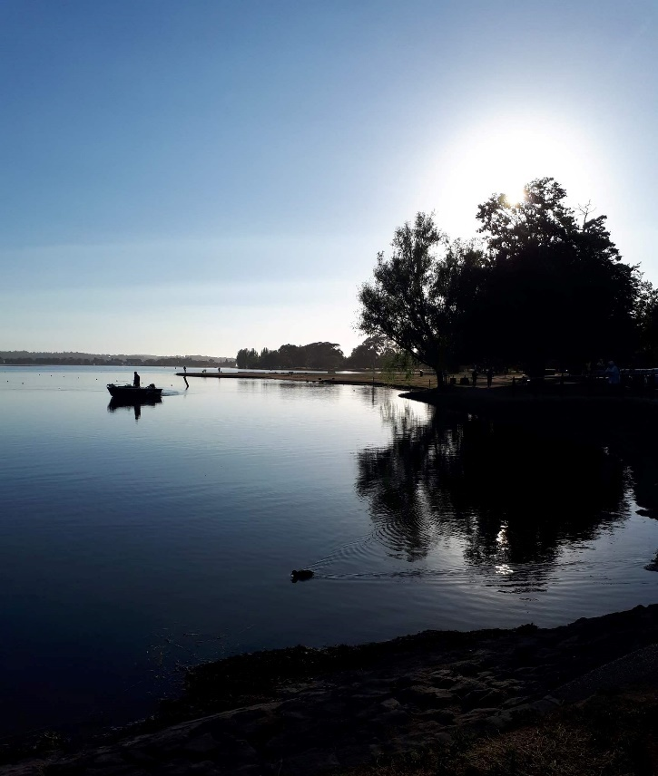
Fishing at sunrise on Lake Wendouree. Source: T. Thorpe 2020

National Rural Health Alliance (2020). Adapting rural physiotherapy placements for COVID-19. Partyline, Issue 71, DOI: https://www.ruralhealth.org.au/partyline/issue/71

