Trish Thorpe  Going Rural Health | The University of Melbourne Department of Rural Health  Ballarat, Wangaratta and Shepparton, Victoria

2021 Student Placement Survey Report
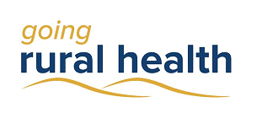
Trish Thorpe

Introduction
Going Rural Health (GRH) is a student program that supports nursing and allied health students to complete a clinical placement in a rural setting in regions of Victoria. At the end of their placement, GRH students are invited to complete a placement evaluation survey. This report is a brief summary of the survey responses from students who completed a placement in 2021.

The COVID-19 Context
During the months of ‘hard’ lockdowns (stage 4 restrictions), regardless of DHHS guidelines which allowed students to travel for placements, many regional and rural health care services ceased or lessened clinical placements, some did not want students from Melbourne, and other placements restricted students from COVID ‘hot spots’. This lessened the availability of rural placements.
Some rural health services also indicated that their staff were less accepting of students coming from high COVID areas, perceiving staff to be unhappy with the risk these students posed to the rural community. This is demonstrated by the survey comment below:
‘Current best based practice with DHS is to allow students (from) high risk zones and fit test them. I needed to advocate for this change.’
Changes in regards to compulsory vaccination requirements only briefly caused some consternation in 2021, mainly due to initial vaccine shortages, difficulties getting vaccination appointments, or long vaccination queues. Students generally complied with DHHS guidelines and time frames once supply was assured.
GRH staff worked remotely from home most of the year, as in 2020. Connecting with students was more difficult and social isolation of students while on placement again was a risk. To address this, the team continued to organise online student engagement events in collaboration with the Rural Clinical School team, and the Regional Training Hubs from the Department of Rural Health.
For a second year, education sessions were provided in virtual or online formats, and the GRH team developed an online Learning Centre on the GRH website, consolidating all online courses on the one platform. Education sessions were promoted via social media platforms, the growing GRH newsletter, and directly at meetings.
GRH staff adapted to the rapidly changing landscape, again offering extra support to students and stakeholders as required, or planning to switch to virtual placements (either whole or in part) at short notice when necessary. Sometimes all that was required was a slight delay in the placement start to ensure all was in place for the placement to go ahead.
Students only rarely mentioned COVID negatively in relation to their placements, but when they did it was often a statement of fact they accepted couldn’t be changed. This is possibly due to having lived with COVID and the restrictions for an extended period, and adjusting quickly to changes as they occurred. As one student commented:
‘COVID has made placement difficult. However, it is part of the experience.’
Some rural towns and health services had extensive outbreaks, which heavily impacted student placements. As one student said:
‘During my placement there was a lockdown at my facility due to a COVID outbreak. This impacted my placement as some days I did not have much I could do as I couldn't go see patients or clients. This was for the majority of my placement and could only participate in community patient sessions.’
Despite this situation, the student still indicated that they were satisfied with their placement.
Students also commented on the support and time given to them despite the stresses of COVID:
‘… My CSNs were fantastic and very supportive. The nurses in charge and the senior nurses all offered great support and knowledge. They were able to guide me to fill in my gaps which were lost from not having lab time during COVID.’
‘(Staff) were also very supportive in understanding that it was my first placement and that I had little practical time in labs due to COVID.’
‘I think my experience was somewhat shaped by the COVID lockdown that occurred whilst I was on placement. This meant I could not travel back home for the duration of the placement and I was the only one in the student accommodation. This made the experience isolating at times as I could not even explore the surrounding area. However, the support I received from my placement provider during lockdown made the experience very positive for me and highlighted the sense of community in a rural town.’
‘Thanks to everybody for enabling placement throughout COVID.’
‘Supervisors were lovely and I was able to learn a lot regarding rural communities and particularly the impact COVID can have on them especially seen as I was placed on a cross-border community.’
Students also mentioned some benefits of what had been implemented due to COVID:
‘…Telehealth modules were so great given COVID has changed how we work. It's made me think of how I can use this in my future career.’

Student Demographics
Over 800 survey responses were collected from the student survey, an increase of approximately 100 from 2020, and similar to 2019 responses. Of the respondents, 84% of students were female. Student ages ranged between 17 and 60 years. 57% of students had lived in a regional or rural area previously, lower than in 2020, indicating an increase in rural placements in 2021 for metropolitan students. 63% were nursing students, similar to 2019 participants, as there were fewer allied health placement cancellations compared to 2020. 16 allied health disciplines were represented. Students came from 16 different education providers. Further, 58% of placements were located in a public hospital. This was lower than in 2020 (70%), due to increased community-based placements.

Placement Satisfaction
Going Rural Health students in general reported positive rural placement experiences. There was a slight increase in overall placement satisfaction for the year, compared with 2020.
Of those who indicated dissatisfaction (5%), negative comments included that they did not feel their placement was acute enough or they were dissatisfied with their clinical supervisor or the amount of clinical supervision provided. More than half of the students who indicated they were dissatisfied with their rural placement also reported in their comments that they actually enjoyed their placement experience. Reasons for their dissatisfaction is unknown.

92% of GRH students were satisfied with their rural placement

Positive aspects reported by students included:
- Welcoming and friendly staff, patients and community (57%)
- The variety of patient presentations and learning experiences (40%)
- Staff time given to support learning (32%)
- Teamwork, within and across teams (18%)
Students often mentioned the slower pace, less traffic congestion, shorter travel times, and the entire experience of living rurally as positives. Comments included:
‘This placement provided me an opportunity to explore a part of the countryside in Victoria. I had never been to a rural area before, but placement allowed me to enjoy the pureness and peaceful(ness) from this little small town.’
‘(I liked)…the quiet community and beautiful rural landscapes. Every healthcare member I encountered were also very supportive and welcoming.’
‘It was a great opportunity to see rural living’

Student Learning
Students were asked what they thought contributed most to the education experience on their rural placement. Three main responses emerged:
- Great preceptors and supportive environment (53%)
- Broad range of learning experiences (38%)
- Hands-on experience and independence (27%)

85% of students felt that their rural placement improved their work readiness.

47% of students had inter-professional education provided during their placement, a reduction to 2020 levels. 19% of students were unsure whether they had received this type of education, an increase compared with 2020 levels.
Some comments from students about their rural placement learning experience included:
‘…The nurses in charge and the senior nurses all offered great support and knowledge. They were able to guide me to fill in my gaps which were lost from not having lab time during COVID….’
‘Being in a small facility was definitely an advantage. I felt (like) I wasn't 'lost' or pushed aside. There was always someone wiling to take me on and show me their role and support my learning’
‘My supervisor was not very attentive to my learning. I think that could definitely be improved.’
‘Great relationship with a supervisor who was supportive and promoted life long learning, ability to see a different range of clients, (and) ability to undertake independent learning.’
‘The culture and staff within the practice were extremely supportive and approachable and always gave their time generously to assist me with my learning. If I was in a bigger organisation, it may have been more difficult to have this type of access to knowledge and support.’

Supervision Satisfaction

90% of students were satisfied with supervision of their rural placement

90% of students reported that they received good supervision from their preceptors on rural placements, just higher than in 2020.
A large number of students mentioned how impressed they were with the time supervisors dedicated to their learning and how well they were treated by supervisors. Some were also singled out and mentioned by name as being exemplary supervisors.
The most common reason for dissatisfaction surrounding supervision was still that students wanted more time with their clinical educator, especially in the case of nursing students.
‘More time and access to educator.’
‘Perhaps more time with the clinical supervisors.’

Aboriginal and/or Torres Strait Islander Students
1.1% of students completing the survey identified as Aboriginal and/or Torres Strait Islander. Almost all were studying nursing – most at Bachelor level.
Most Aboriginal and/or Torres Strait Islander students found their placements to be positive, praising their preceptors, the placement sites, and the communities. Those who didn’t expressed the need for more supervisor support in their learning, or dissatisfaction with the attitudes of staff towards students.

Cultural Training
52% of students had received cultural training prior to their rural placement while 36% of students did not receive cultural training prior to, during, or after their rural placement. This is consistent with 2020 data, even with the implementation of the GRH online cultural awareness training course for students. Further promotion of this course, as it is easily accessible to all students, could address this.
69% of students felt that the cultural training they were provided was adequate, around 10% less than in 2020. A large number of students found their training neither adequate nor inadequate. This may be due in part to the reduction in face-to-face cultural awareness training workshops provided, due to COVID restrictions.

Student Accommodation
Students again found it challenging to source accommodation in 2021, mainly due to student accommodation being at capacity for much of the year. Students in these situations managed to source private accommodation, mainly via Air BNB, but commented on the extra cost of their placement. Some students were also upset that they had lower priority regarding accessing accommodation than medical or dental students.

‘more accommodation needs to be provided for students at a reasonable cost (so) more students would be willing to put rural opportunities on their preferences’

Of those who stayed in university or hospital accommodation, some of the issues raised were:
- Providing more and timely information about the accommodation prior to arrival
- Communication with students during their stay
- Accommodation cleanliness, including slovenly habits of long term residents
- Accommodation needing maintenance
- Wi-fi issues
Some students also commented that they were unaware of supports and low cost accommodation available prior to placement. Further promotion of accommodation options in specific regions could assist with this.

GRH Support
Financial assistance, subsidised accommodation, virtual education, placement matching, funding of supervision and placement creation were some of the services provided to students, placement sites and universities in 2021. 50% of students received financial assistance from GRH, an increase from 2020 numbers.
82% of students were happy with GRH support. Comments from students included:
‘Great support from the Going Rural Health team’
‘It was nice that Going Rural Health has many events open to students to join and learn about.’

‘I really appreciate the warm welcome and ongoing support from Going Rural Health.’

GRH staff have provided supervision, discipline specific and interdisciplinary online education sessions, as well as simulated patients for assessments and therapy demonstrations. Mentoring was provided to students in addition to supervision support.
Many student engagement events were run virtually to reduce student isolation and improve their social experience while on placement. These included virtual cooking classes, quizzes, virtual coffee tastings (with tasting packs sent to participants), and the highly successful ‘Fright Night’ – old horror movie packs for Halloween – which was just what students appeared to need prior to the exam period.

Conclusion
Like 2020, 2021 was a challenging year for students, supervisors and GRH staff. Again, many placement sites went above and beyond to place students and support them while on placement at this difficult time. A number of community based rural placements, which did not proceed at all in some cases in 2020, were completed in 2021. Community based placements were also extended in 2021, and this will continue into 2022, providing much needed placements for students, and services for the communities involved.

Acknowledgements
GRH would like to thank our health service and placement partners for continuing to support students at such a challenging time – it has been a changing landscape requiring innovation and adaptability. GRH also thank the many universities who continue to be committed to rural education and sending students to rural Victoria. Finally, GRH acknowledges support from the Australian Government Department of Health Rural Health Multidisciplinary Training Programme.

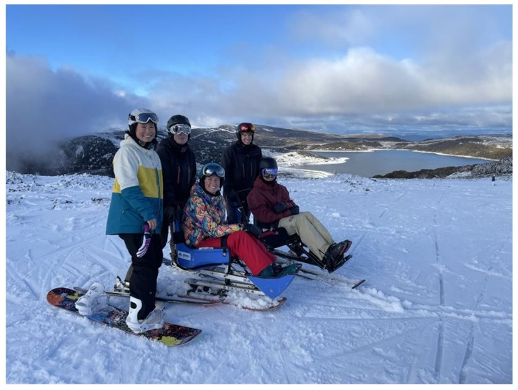
Physio students at DWA Snow Placement Nov 2021

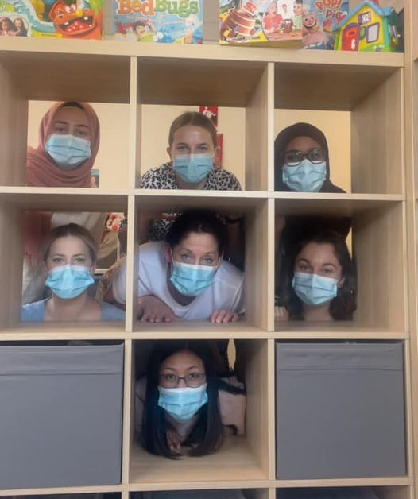
Speech Pathology students at the Shine Centre, Sept 2021

If you have any questions about rural placements or what GRH provide, please contact us at going-ruralhealth@unimelb.edu.au or via www.goingruralhealth.com.au

