Trish Thorpe  Going Rural Health | The University of Melbourne Department of Rural Health  Ballarat, Wangaratta and Shepparton, Victoria

2022 Student Placement Survey Report
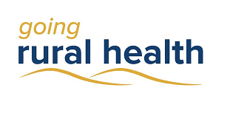
Trish Thorpe

Introduction
Going Rural Health (GRH) is a student program that supports nursing and allied health students to complete a clinical placement in a rural setting in regions of Victoria. The GRH team supported 965 students to undertake a rural placement in 2022. At the completion of their placement, students supported by GRH were asked to fill out a questionnaire. A total of 642 students completed our questionnaire. The results are presented here.

Student Demographics
GRH supported students from 14 different universities as well as TAFEs. Of these students, 84% identified as female and 2% as Aboriginal and/or Torres Strait Islander. The median age was 23. 58% of students had grown up in a rural, regional or remote area while 42% had grown up in a city. Further, 57% were studying nursing and midwifery and 43% were studying an allied health discipline.

Overall Placement Satisfaction
Most students were satisfied with their rural placement (see Figure 1).

Figure 1: Student placement satisfaction (agreement)

93% of GRH students were satisfied with their rural placement

Student Learning During Placement
Students provided positive feedback about their education during the rural placement. Of those surveyed, 93% indicated that they ‘learned a lot during my placement.’ Further, 90% said they had ‘adequate educational resources’ and 90% indicated that they felt ‘part of the team.’ However, 45% responded that they wanted more learning opportunities during placement.
Students were generally positive about their placement supervision; 91% were satisfied with the supervision they received on placement and 91% felt their ‘supervisor responded to their learning needs.’ Students appreciated being placed with another student, staff and preceptors who were ‘supportive’, having ‘consistent supervision,’ ‘enthusiastic teachers’, being visited regularly, being challenged in a supportive way and being ‘supported generally’ by the team.
Students were generally satisfied with their caseload, describing it as ‘appropriate’, ‘perfect amount of work’ and ‘a good balance’. A few described their caseload as ‘heavy’, ‘small’, ‘restricted’ or that they would have liked more.

91% of students were satisfied with supervision of their rural placement

Impact of their Placement
Students were positive about the impact of their learning during placement. 93% felt ‘more prepared to work in my field of study as a result of my placement.’ In addition, 90% agreed ‘I was supported to work independently during my placement.’
Students also said they felt their work during the placement was valued. In all, 88% responded that they felt they contributed to the health service and 91% felt they contributed to the patients and the community.

Rural Practice
In terms of learning about rural practice, 80% reported that they ‘learned about working and living in rural areas.’ On this questionnaire, 53% of students indicated that prior to their placement they would consider living and working in a rural, regional or remote area. 65% suggested that this placement has encouraged me to consider living and working in a rural, regional or remote area.

Going Rural Health Support
A total of 79% of students responded that GRH positively contributed to their placement experience through good communication, being supportive, financial assistance, tutorials and education sessions, by resolving issues and helping with questions, with accommodation, mentoring and debrief sessions. Some students wanted the financial assistance paid in advance and others wanted a smoother online application process.
Students were less positive about their accommodation during placement; of these students, 60% were satisfied with their accommodation. Not all respondents stayed in University of Melbourne accommodation. Reasons for accommodation dissatisfaction included cost, availability, wi-fi access and speed, cleanliness, facilities, & other residents.

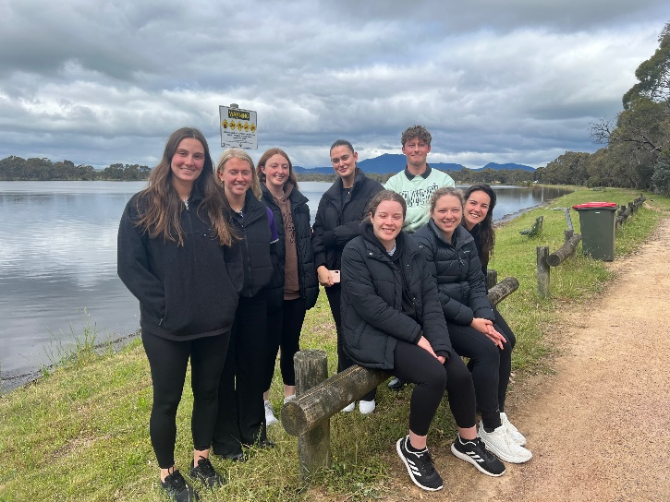
Students on Halls Gap Cultural Awareness Training day November 2022

Service Learning
Of all GRH students, 146 completed a Service Learning placement. In these placements, students use their skills to provide a health service that would otherwise not be provided. In these placements, students provided care for primary and secondary students with a disability, speech pathology in primary schools, wellbeing education to school students and staff, projects for schools and community groups and providing transitional care, rehabilitation and aged care at health services without these services. Of these students, approximately 89% suggested they were satisfied with their placement, 90% indicated they learned a lot, 88% were satisfied with their supervision and 90% felt supervisor responded to their learning needs. In addition, 84% said they were supported to work independently, 90% feel more prepared to work in their field and 86% felt they made a contribution to patients or community.

Improvements for Placements
When asked, 40% responded that no improvements were needed. Other students suggested more learning opportunities, greater financial assistance and better communication between all stakeholders involved in a placement (university staff, health services, GRH and so forth).

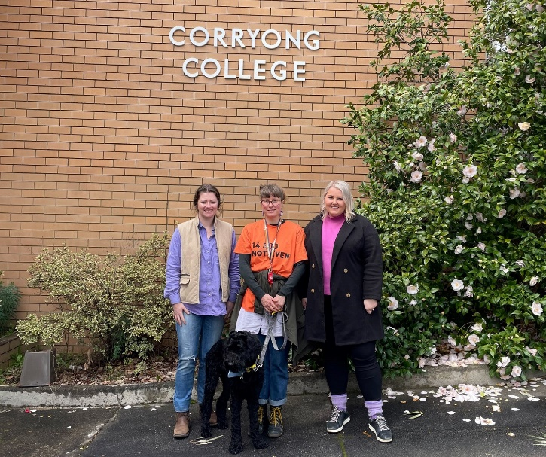
OT students on placement at Corryong College 2022
See https://goingruralhealth.com.au/allied-health-placement-benefiting-small-community/ for more details of this placement.

‘It would be great if it could be standard to have at least two students go for the placement together’

Conclusion
2022 was a busy year for GRH, supporting our largest number of Service Learning and also Social Work students as well as new members joining the team.
If you have any questions about rural placements or what GRH provide, please contact us at going-ruralhealth@unimelb.edu.au

Acknowledgements
GRH would like to thank our health service and placement partners for their continued willingness to support & educate students. GRH also thank the many universities who are committed to rural education and sending students to rural Victoria.
This activity has been supported by the Australian Government Department of Health through the Rural Health Multidisciplinary Training programme.

