Trish Thorpe  Going Rural Health | The University of Melbourne Department of Rural Health  Ballarat, Wangaratta and Shepparton, Victoria

2023 Student Placement Survey Report
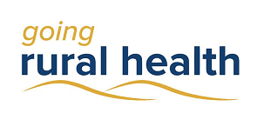
Trish Thorpe

Introduction
Going Rural Health (GRH) is a student program that supports nursing and allied health students to complete a clinical placement in a rural setting in regions of Victoria. The GRH team supported 1132 students to undertake a rural placement in 2023, including 169 students that were supported more than once. At the completion of their placement, students supported by GRH were asked to fill out a questionnaire. A total of 285 students completed this (25%), a significant reduction to previous years. The results are presented here.

Student Demographics
GRH supported students from 12 different universities as well as some TAFEs. Of these students, 87% identified as female and 2% as Aboriginal and/or Torres Strait Islander. The median age was 25. About two thirds (62%) of students had grown up in a rural, regional or remote area while 38% had grown up in a city. Further, 67% were studying nursing and midwifery and 33% were studying an allied health discipline.

Overall Placement Satisfaction
Most students (94%) were satisfied with their rural placement (see Figure 1).

Figure 1: Student placement satisfaction (agreement %)

94% of GRH students were satisfied with their rural placement

Student Learning During Placement
Student education during their rural placement was viewed favourably. Of those surveyed, 95% indicated that they ‘learned a lot’ during their placement. Further, 84% said they had ‘adequate educational resources’ and 89% indicated that they felt ‘part of the team.’ However, 42% responded that they wanted more learning opportunities during placement.
Students were generally positive about their rural placement supervision; 94% were satisfied with the supervision they received on placement and 91% felt their supervisor responded to their learning needs. Students commented that supervisors were supportive, approachable and/or welcoming (47%), good or excellent (29%), and provided them with opportunities to work independently. One student commented: ‘I was supervised by different supervisors at least once a week and given feedback based on that. I was also able to discuss consults with supervisors and debrief if necessary. It was a good balance between supervision and independence.’
Most of the students (91%), reported they were satisfied with their caseload for their stage of learning describing it as ‘good’ or ‘appropriate’ in most cases. For example, one student commented: ‘appropriate caseload that increased as I became more confident’, and another commented; ‘not overwhelming, but it was enough for me to learn and reflect’. A few described their caseload as ‘restricted’, ‘small’, not advanced enough for their stage of learning, or that they would have liked more. Some students commented they felt their presence was utilised as an extra number rather than in addition to the usual staff load.

94% of students were satisfied with supervision of their rural placement

Impact of their Placement
Students were positive about the impact of their learning during placement. The majority (92%) felt ‘more prepared to work in my field of study as a result of my placement.’ In addition, 90% agreed ‘I was supported to work independently during my placement.’
Students also said they felt their work during the placement was valued. In all, 86% responded that they felt they contributed to the health service and 92% felt they contributed to the patients and the community.

Rural Practice
Looking at their placement from a rural perspective, 76% reported that they ‘learned about working and living in rural areas.’ For 2023, 48% of students indicated that prior to their placement they would consider living and working in a rural, regional or remote area, while 62% suggested that ‘this placement has encouraged me to consider living and working in a rural, regional or remote area’. Both pre and post placement, 30% of students were undecided.

Going Rural Health Support
Of the students who responded, a third had direct contact with GRH. Of these, 74% agreed that GRH positively contributed to their placement experience through good communication, being supportive, providing financial assistance and accessible accommodation, providing education and workshops, resolving issues and answering questions, and providing mentoring support. A few students had issues with the application process and communication surrounding accommodation, and some would have liked more financial support. Still others had not heard of the support until the end of their placement.

‘Between the financial support, ongoing educational support, and the mental health lens, this was a very well-rounded placement experience.’

Students were asked about their accommodation during placement. Of those who utilised health service or University of Melbourne accommodation, 83% were satisfied with their accommodation. Reasons for dissatisfaction were most commonly cost and availability.

Service Learning
Of all GRH students, 116 (10%) completed a Service Learning placement. In these placements, students use their skills to provide a health service that would otherwise not be provided. On these placements, students provided:
- Care for primary & secondary students with a disability
- Speech pathology in primary schools
- Social skills & emotional regulation groups for schools
- Projects and therapy for schools & community groups
- Transitional care & rehabilitation after surgery or injury
- Allied health for aged care.
Of the survey participants who indicated they completed a Service Learning placement (9), all selected they were satisfied with their placement and that they ‘learned a lot’, 89% (8) were satisfied with their supervision and 89% (8) felt the supervisor responded to their learning needs. In addition, all said they were supported to work independently, all felt more prepared to work in their field as a result of their placement, and 89% (8) felt they made a contribution to patients or community.

Improvements for Placements
Participants were asked what would have improved their placement experience. 43% responded that no improvements were needed. The most common responses after this were more learning opportunities or education (21%), greater financial assistance or more accommodation (19%), and better communication between all stakeholders involved in a placement or with the student (18%).

‘I did not experience any negatives and felt my experience demonstrated how the nursing community in rural areas are important and how much the community depend on them.’

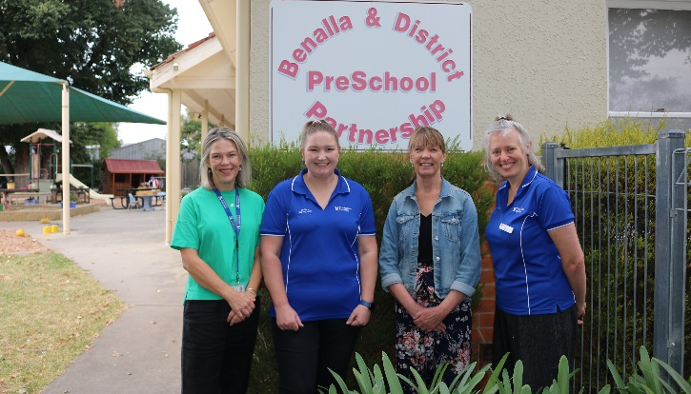
OT students on placement at Benalla Preschool 2023

Conclusion
Overall, 2023 was a difficult year in some regards for GRH, with many placement cancellations at health services and other placement sites. However, GRH supported a large number of successful Service Learning placements, including those at new sites, & welcomed new members to the team.
If you have any questions about rural placements or what GRH provide, please contact us at going-ruralhealth@unimelb.edu.au

Acknowledgements
GRH would like to thank our health service and placement partners for their continued willingness to support & educate students. GRH also thank the many universities who are committed to rural education and sending students to rural Victoria.
This activity has been supported by the Australian Government Department of Health through the Rural Health Multidisciplinary Training programme.

